2026 CHEME CUBE CHEMICAL SCREENING TOOL
University Name:
Team Name:
Team Lead:
Team Advisor:

Please indicate (in general) which type of process your team intends to use for the 2026 Direct Air Capture of CO2 competition:
General Process |  | Description
Electrochemical |  | Uses electrical fields/charges to separate CO2 from air
Mechanical Separation |  | Uses membrane/molecular sieves to mechanically filter CO2 from Air
Dissolution |  | Process where CO2 dissolves into liquid solution
Adsorption/Absorption |  | CO2 is captured by solid matrix either
Briefly Describe your proposed CO2 capture mechanism. Include list of Chemicals/Reagents/Sorbents (etc.) required:
Description:
Y/N | Please verify that team DOES NOT plan to use any chemical, raw material, intermediate or product that is highly reactive or unstable. This includes chemicals with a GHS hazard category level 1 ranking in any of the following categories; pyrophoric solids and liquids, hazardous to the ozone layer and any chemical on the extremely hazardous substances list published by EPA.

Chemical Health and Handling Hazard Review
Review SDS sheets for each chemical/material team proposes to use in the 2026 Competition. In boxes below (add more as needed) list chemical and insert an image of the SDS hazard classification related to health, toxicological or reproductive hazards (see example).
Chemical 1: (example) Ethanolamine (type of MEA)
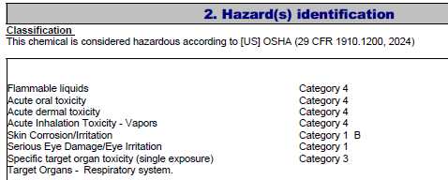
In boxes below (add more as needed) list chemical and insert in image of the SDS handling requirements including incidental exposure (if available) and respirator use.
Chemical 1: (example) Ethanolamine (type of MEA)
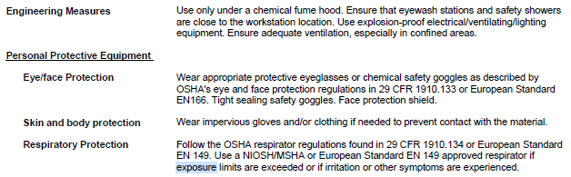
CHEME Cube Chemical Safety Guidelines
- Teams may not DIRECTLY use any chemicals/materials with Class 1 Health-related ratings (like the MEA example, above). Use of these materials is allowed if trace quantities are immobilized into a solid matrix. For example, creating a MEA coated membrane or substrate.
- Use of chemicals with restrictive handling requirements such as: use under a chemical fume hood or use a respirator when handling is allowed with the following caveats:
  - Direct handling/use at the Chemical is not allowed at the Competition Site
  - Materials need to be fully enclosed in sealable vessels that are installed into the Team’s cube just prior to competition. In this configuration, the weight of the vessel is included in the reagent weight calculation scoring parameters.
  - The sealable vessel should have sufficient guards (screens, filter mesh etc) to prevent release of the material during handling, cube operation, installation into and removal from the Cube.
  - The Vessel may not be ‘recharged’ at the competition site, rather the team should provide additional sealed, full vessels as needed for additional runs.
- Teams are responsible for shipping the sealed vessel to the host university in compliance with DOT hazard shipping regulations.
  - Following the competition, the vessels will be resealed and disposed of as chemical waste or
  - If material is non-hazardous, shipped back to the team’s university using return shipping containers/labels provided by team

